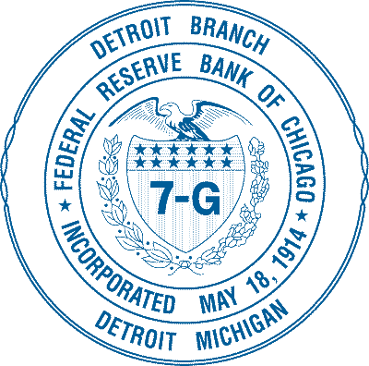
Federal Reserve Bank of Chicago-Detroit Branch

Teacher Workshop for High School and Middle School
Night at the Fed Series—
Supply and Demand
Real life applications of the Laws of Supply and Demand
Sponsored by the Federal Reserve Bank of Chicago-Detroit Branch and Michigan Council on Economic Education
Wednesday, March 6th, 2013
4:00-8:00pm
The event includes a FREE buffet dinner with open bar, tours, and presentations. Registration is open and available on a first-come, first-served basis. Educators would be allowed to bring one guest.
.3 SB-CEUs offered through MCEE ($5 registration fee paid to MCEE the night of the workshop)
Location: Federal Reserve Bank of Chicago-Detroit Branch, 1600 E. Warren Ave., Detroit, MI 48207
The Federal Reserve Bank of Chicago-Detroit Branch would like to give educators some fresh ways in teaching and explaining the workings and mechanisms of the vaunted supply and demand curves. After an introduction and refresher of supply and demand principles, Katy Gustafson, Farmington High School, will engage educators in an activity that can be used in the classroom to better explain and apply the concepts of supply and demand.
For more information and registration, please contact Martin Lavelle at martin.lavelle@chi.frb.org or 313-964-6150

