F
Metro West

Attention: CEOs, CELO’s, Executive Team and Management Staff Senior Management

Open House & Networking Session

You are invited to the Metro West Chapter open-house and networking session to enjoy
hors d’ oeuvres, open bar, dessert and featured speaker Dave Adams, President and Chief Executive Officer, MCUL & Affiliates provides an update on industry opportunities and trends.

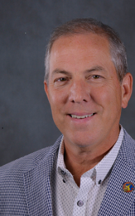

Tuesday, March 1, 2016

5:00 p.m. – 7:30 p.m.

No Cost

Detroit Athletic Club
214 Madison Ave.
Detroit, MI 48226

RSVP BY: February 23, 2016
To attend, please fax or email your reservation request to:
Eric Esser, Community Financial Credit Union
500 S Harvey, Plymouth, MI 48170
Phone: (734) 582-8810 Fax: (734) 582-8811 E-mail: eesser@cfcu.org

Credit Union Name: _____________________________________________

Contact Person: ________________________________________________

Phone: __________________________

Number of Attendees: ______

Attendees(s)___________________________________________________________

______________________________________________________________________

