

2015 Mid-Michigan Chapter Golf Outing
Proceeds to benefit Biz Kids and the Michigan Credit Union Foundation.


Wednesday, August 5, 2015 • 10:00 a.m. – Shotgun Start

Maple Leaf Golf Course
158 N. Mackinaw Road, Linwood, MI 48634
(North of Bay City - East of I-75) Phone: (989) 697-3531

Cost: $60.00 per Golfer
Includes 18 holes of golf with cart, hot dog lunch “at the turn,”
dinner after golf (cash bar) and prizes for everyone!

Mulligans: $5 contribution to MCULLAF
(Contributions to MCULLAF or MCULAF are not considered charitable contributions or business expense for income tax purposes. Contributions are voluntary and there will be no reprisal for not contributing.)

Wanted: Donations for door prizes and skill prizes. If you can donate, please indicate on the attached confirmation slip and bring the donation with you on August 5, 2015.

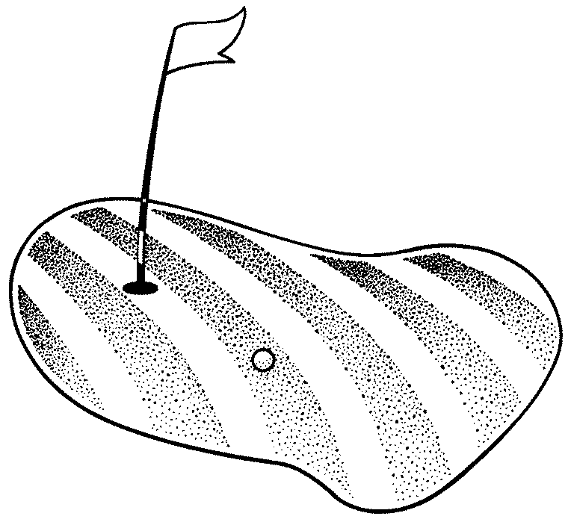
Reservation Deadline is Wednesday, July 29, 2015

Please mail this form and your draft/checks payable to Tim Benecke to:
Wildfire Credit Union
Attn: Tim Benecke
P.O. Box 3285 • Saginaw, MI 48605-3285

Contact Person:_________________________________________________ Phone: __________________________________________________

CU or Company :___________________________________________________________________________________________________________

Address: _______________________________________________ City: _______________________________ Zip: _________________________

Number of golfers: _______________ x $60 = $ ________________________

Names of golfers in foursome: (All welcome! We will match you with someone, if unable to get a foursome).

1_________________________________________________ 3__________________________________________________________
2_________________________________________________ 4___________________________________________________________
Yes, we wish to donate a door prize. Item: _______________________________________________________________________
Contact Person __________________________________________________ Phone ________________________________________________

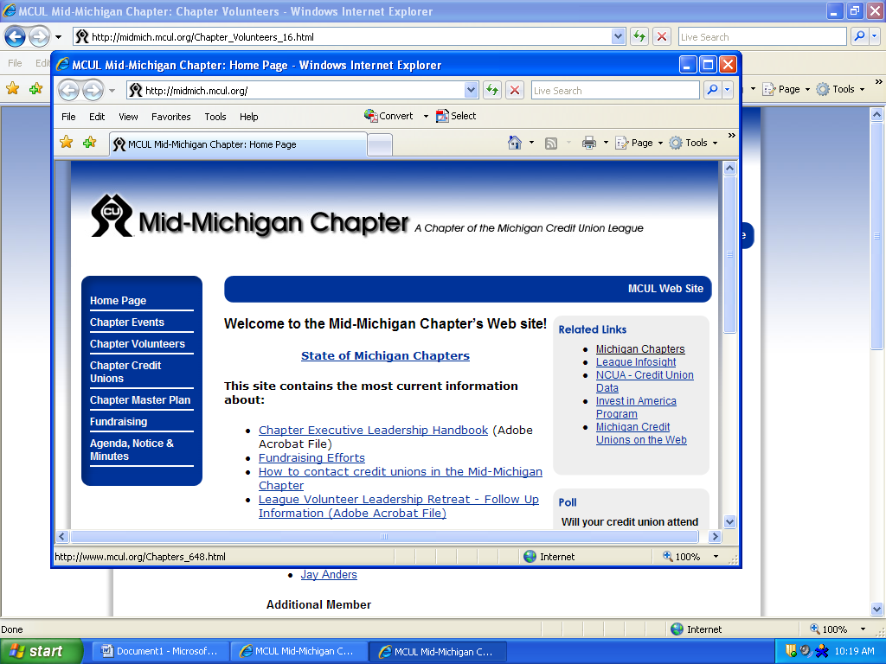

2015 Mid-Michigan Chapter Golf Outing
Sponsorship Opportunities

The Mid-Michigan Chapter of Credit Union’s Annual Golf Outing is coming soon. As this is a cooperative effort, we would appreciate your consideration in becoming one of the sponsors.

The outing is on Wednesday, August 5, 2015 at the Maple Leaf Golf Course at 158 N. Mackinaw Road, Linwood, MI 48634 (North of Bay City; East of I-75).

Each year, the golf outing proceeds are donated to a worthy cause that benefits Mid-Michigan and/or the Michigan Credit Union Foundation.


The proceeds in 2015 will support the Chapter’s financial literacy efforts by airing a weekly show geared to young people, titled “Biz Kids.” With your support, a new season of Biz Kids will air weekly on both Delta’s Q-TV and CMU Public TV, fully sponsored by the Mid-Michigan Chapter of Credit Unions. The creation and production of Biz Kids is sponsored by America’s Credit Unions, and recently won an Emmy for its “money smart focus.” To learn more, go to www.BizKids.com.

The proceeds will also support the Michigan Credit Union Foundation. The Foundation provides educational scholarships and grants for Michigan credit unions and chapters for the purposes of supporting credit union member services, community outreach, employee educational development, and strengthening the Michigan Credit Union Movement.

Sponsorship Opportunities:

Hole Sponsor - $150.00 (per hole) Contest Sponsors - $200.00

Sponsorships must be prepaid and received by July 29, 2015, to receive signage at the outing. Please provide the information below, and mail a check payable to Tim Benecke to the following address:
Wildfire Credit Union
Attn: Tim Benecke
P.O. Box 3285
Saginaw, MI 48605-3285

Sponsorship Information:

Company/CU Name: _______________________________________________________________________________________

Contact Person: _____________________________________________ Best time to call: ____________________________

Phone Number: _____________________________________________ Email: ________________________________________

Address: _____________________________________________________________________________________________________

Please send your logo (electronic .jpg -- preferred format) to Tim at tbenecke@wildfirecu.org.

